# Process Peer review

During this project you have worked together as a group. During this collaboration you may have noticed certain good or bad behaviour from yourself, your group members, or your group as a whole. This process peer review exists out of two parts: 1) Group dynamics with Lewis self-test and reflection, 2) constructive feedback about behaviour during group work.

Be sure to submit the process peer review on time as it will be discussed during the project meeting with you tutor.

## 1.Group dynamics realted cultural differences

Include below the *Lewis triangular diagram*, containing plot of all group members, you made during WKS:

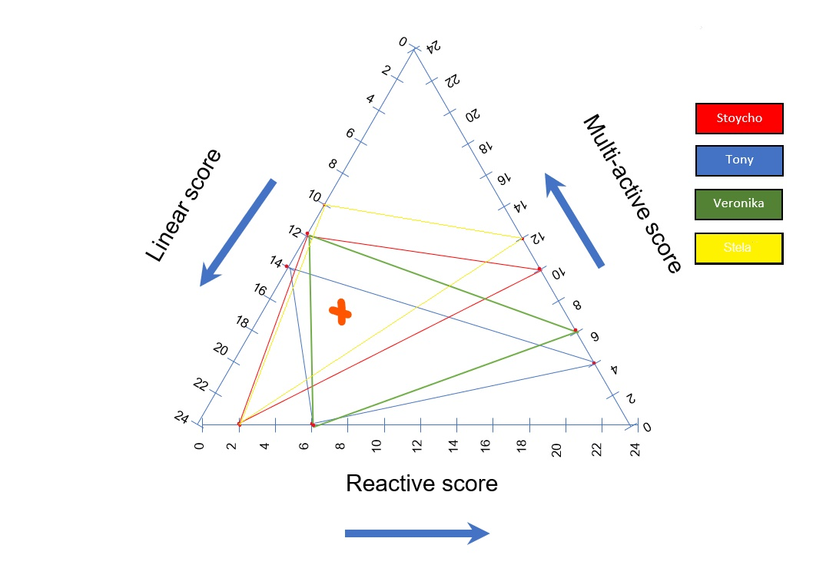

Specify below where do you see potential synergies and frictions between group members related to the expectation of PRJ?

Our potential synergies in the group is that we like to plan ahead what each person is doing, because we all scored high on linear-active, where it's more task oriented. The synergies comes from helping each other on application and task on the documentation.

The friction of are group is that someone is not doing their task and not updating eah others on their task. Oftentimes members of the group do not update the other members of their progress until they are ready with their work. That way we are doing everything the last minute and that creates tension between the group members and the group as a whole is not aware of what we have as a overall progress till the end of the delivarable. Half of our group members are more on the multi-active and the other half is more on the reactive and the interaction sometime will take long.

## 2. Constructive feedback

Below you find a table that is intended for you to convey what your impression is related to the work contribution of each member towards the project. Please indicate in percentages how you perceived the work division was per item.

|  |  |  |  |  |
| --- | --- | --- | --- | --- |
| **Item worked on** | Stoycho Stoychev | Tony Jiang | Stella Trencheva | Veronika Valeva |
| *Process (making agenda's, minutes, being chairperson, etc.)* | 30% | 20% | 30% | 20% |
| *Project plan* | 10% | 10% | 40% | 40% |
| *URS* | 15% | 35% | 30% | 20% |
| *Testplan & Testreport* | 35% | 35% | 15% | 15% |
| *UML Class Diagram* | 25% | 25% | 25% | 25% |
| *C# application* | 25% | 25% | 25% | 25% |
| *Web application* | Choose an item. | Choose an item. | Choose an item. | Choose an item. |

Lastly, below you can find a table that is intended for you to include constructive feedback for your team members. Be sure to at least include one constructive feedback per member and this be about thing to keep and/or to improve at.

|  |  |  |  |
| --- | --- | --- | --- |
|  | Situation/behaviour | Effect/impact | Need/Way forward |
| Stoycho Stoychev | Getting calls at random times without messaging me or letting me know. | I can't focus on programming the application. | Need to message first if I'm available to talk. |
| Stela Trencheva | Late on showing how the functionalities of the scheduling work. | We don't know how the scheduling works and don't know how to help. | After completing the functionalities you should show us how it works. |
| Veronika Valeva | Being late for the tutor meeting. | We have to wait for her before we start | If you need help waking up or you can't make it on time let us know. |

Below you are expected to assign a grade between 0 and 10 per group member (including yourself) on how well the person contributed to the project, and how proactive this person was.

|  |  |  |  |  |
| --- | --- | --- | --- | --- |
|  | Stoycho Stoychev | Tony Jiang | Stela Trencheva | Veronika Valeva |
| Contribution to project | 9 | 7 | 9 | 9 |
| Proactive attitude | 7 | 6 | 8 | 8 |